- Write a C program to count the vowels in a string.
#include<stdio.h>
int main()
{
char str[100];
int i,count=0;
printf("enter a string: ");
scanf("%s",&str);
for(i=0;str[i]!='\0';i++)
{
if(str[i]=='a'||str[i]=='e'||str[i]=='i'||str[i]=='o'||str[i]=='u'||str[i]=='A'||str[i]=='E'||str[i]=='I'||str[i]=='O'||str[i]=='U')
{
count++;
}
}
printf("number of vowels:%d\n",count);
return 0;
}
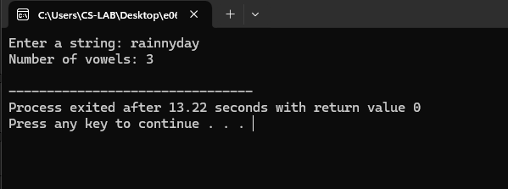

- Write a C program to check if a string is a palindrome or not.
#include <stdio.h>
#include <string.h>
int main()
{
char str[100];6;int i,len,flag=1;
printf("Enter a string: ");
scanf("%s",&str);
len=strlen(str);
for (i=0;i<len/2;i++)
{
if (str[i]!=str[len-i-1]) {
flag = 0;
break;
}
}
if(flag==1)
{
printf("The string is a palindrome\n");
} else {
printf("The string is not a palindrome\n");
}
return 0;
}
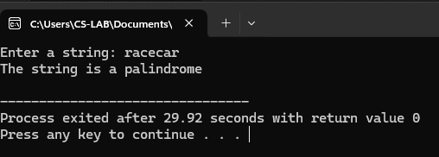
- Write a C program for Finding the Frequency of a Character in a String
#include <stdio.h>
int main() {
char str[100], ch;
int i, count=0;
printf("Enter a string: ");
scanf("%s", &str);
printf("Enter the character to find frequency: ");
scanf(" %c", &ch);
for (i=0;str[i]!='\0'; i++)
{
if (str[i]==ch)
{
count++;
}
}
printf("Frequency of'%c':%d\n",ch,count);
return 0;
}
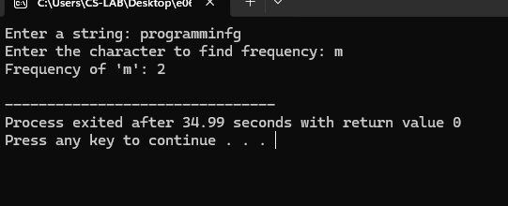

4. Write a C program to perform String operations using Pre-defined functions
(i) strlen
#include<stdio.h>
#include<string.h>
int main()
{
char str[]="Hello, World!";
int length=strlen(str);
printf("The length of the string \"%s\" is: %d\n",str,length);
return 0;
}
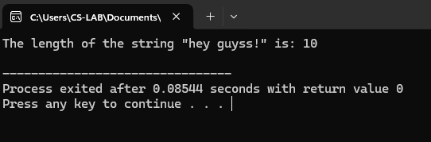
(ii) strcpy
#include<stdio.h>
#include<string.h>
int main()
{
char source[]="Hello, World!";
char destination[50];
strcpy(destination,source);
printf("Copied string: %s\n", destination);
return 0;
}
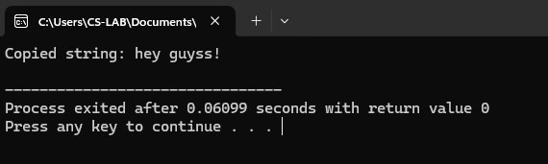
(iii) strcat
#include<stdio.h>
#include<string.h>
int main()
{
char str1[50] ="hey,";
char str2[] ="guyss!";
strcat(str1,str2);
printf("Concatenated string: %s\n", str1);
return 0;
}
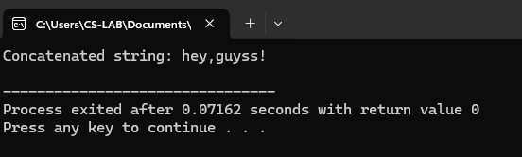
(iv) strcmp
#include<stdio.h>
#include<string.h>
int main()
{
char str1[100],str2[100];
printf("Enter the first string:");
scanf("%s",&str1);
printf("Enter the second string:");
scanf("%s",&str2);
int result=strcmp(str1,str2);
if (result==0)
{
printf("The strings are equal.\n");
}
else if(result<0)
{
printf("The first string is less than the second string.\n");
}
else
{
printf("The first string is greater than the second string.\n");
}
return 0;
}
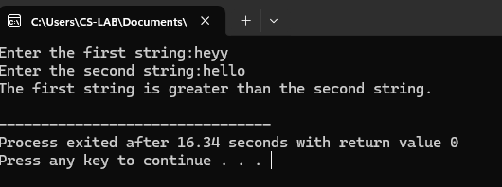

5. Write a C program to perform String operations without using Pre-defined functions
(i) strlen
#include <stdio.h>
int main()
{
char str[]="hey guyss!";
int length=0;
while (str[length]!='\0')
{
length++;
}
printf("The length of the string \"%s\" is: %d\n", str, length);
return 0;
}
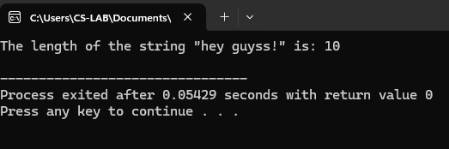
(ii) strcpy
#include <stdio.h>
int main() {
char source[] = "hey guyss!";
char destination[50];
int i=0;
while (source[i]!='\0') {
destination[i]=source[i];
i++;
}
destination[i] = '\0';
printf("Copied string:%s\n",destination);
return 0;
}
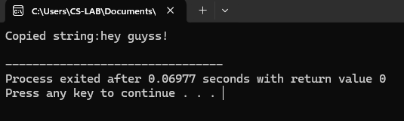
(iii) strcat
#include<stdio.h>
int main()
{
char str1[100], str2[100];
char result[200];
printf("Enter the first string: ");
scanf("%s",&str1);
printf("Enter the second string: ");
scanf("%s", &str2);
int i = 0;
while (str1[i]!='\0')
{
result[i]=str1[i];
i++;
}
int j = 0;
while (str2[j] != '\0')
{
result[i] = str2[j];
i++;
j++;
}
result[i]='\0';
printf("Concatenated string: %s\n", result);
return 0;
}
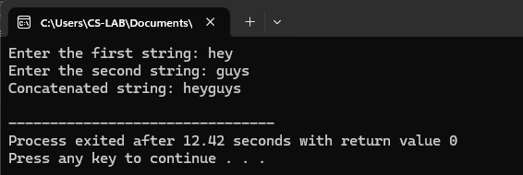

(iv) strrev
#include <stdio.h>
#include <string.h>
int main()
{
char str[] ="hey guyss!";
printf("Original string: %s\n", str);
int n=strlen(str);
for(int i=0;i<n/2;i++)
{
char temp=str[i];
str[i]=str[n-i-1];
str[n-i-1]=temp;
}
printf("Reversed string:%s\n",str);
return 0;
}
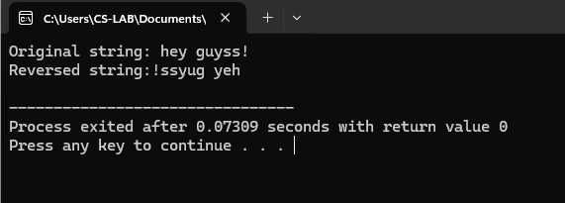
(v) strlwr
#include<stdio.h>
int main() {
char str[100];
printf("Enter a string: ");
scanf("%s",&str);
for (int i=0;str[i]!='\0';i++)
{
if (str[i]>='A'&&str[i]<='Z')
{
str[i]=str[i]+32;
}
printf("Lowercase string: %s\n", str);
return 0;
}
}
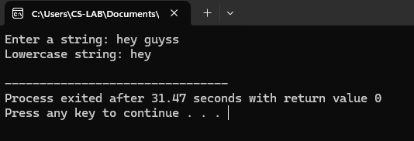
(vi) strupr
#include<stdio.h>
int main()
{
char str[100];
printf("Enter a string:");
scanf("%s",&str);
for (int i = 0; str[i] !='\0';i++)
{
if (str[i]>='a'&&str[i]<='z')
{
str[i] = str[i]-32;
}
printf("Uppercase string:%s\n",str);
return 0;
}
}
